Roll no: 717822P128

Name: Krisha C S

Task 21:

Create variables of different data types (e.g., string, number, boolean, null, undefined, object)

<html>

<haed>

<title>Task 21</title>

</haed>

<body>

<script>

let name = "Krisha";

let rollno = 28;

let state = true;

let user={

name: "Varsha",

rollno: 45

};

console.log(name);

console.log(rollno);

console.log(state);

console.log(user);

</script>

</body>

</html>

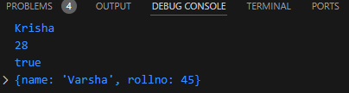

Task 22:

Use the typeof operator to determine the type of various variables.

<html>

<haed>

<title>Task 22</title>

</haed>

<body>

<script>

let name = "Krisha";

let rollno = 28;

let state = true;

let user={

name: "Varsha",

rollno: 45

};

console.log(typeof(name));

console.log(typeof(rollno));

console.log(typeof(state));

console.log(typeof(user));

</script>

</body>

</html>

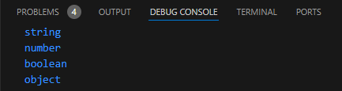

Task 23:

Declare a symbol and print its type

<html>

<head>

<title>Task 23</title>

</head>

<body>

<script>

let sym = Symbol();

console.log(typeof(sym));

</script>

</body>

</html>

